Project Design Phase-II
Data Flow Diagram & User Stories

Date | 23 October 2026
Team ID
Project Name | Electric Vehicle Market Performance & Insights
Maximum Marks | 4 Marks

Data Flow Diagrams:
A Data Flow Diagram (DFD) is a traditional visual representation of the information flows within a system. A neat and clear DFD can depict the right amount of the system requirement graphically. It shows how data enters and leaves the system, what changes the information, and where data is stored.
DFD Symbol Legend
Symbol | Name | Description
Oval / Rounded  shape | External Entity | A person, organization, or system outside the project that sends or receives data (e.g., Customer, Payment Gateway).
Rectangle with  numbered header | Process | An activity that transforms incoming data into outgoing data (e.g., Validate Request, Process Order).
Rectangle (solid fill, no number) | Data Store | A place where data is held for later use (e.g., Customer Database, Inventory).
Labeled arrow | Data Flow | The movement of data between entities, processes, and data stores, labeled with what data is being passed.

Example: DFD Level 0 (Industry Standard)

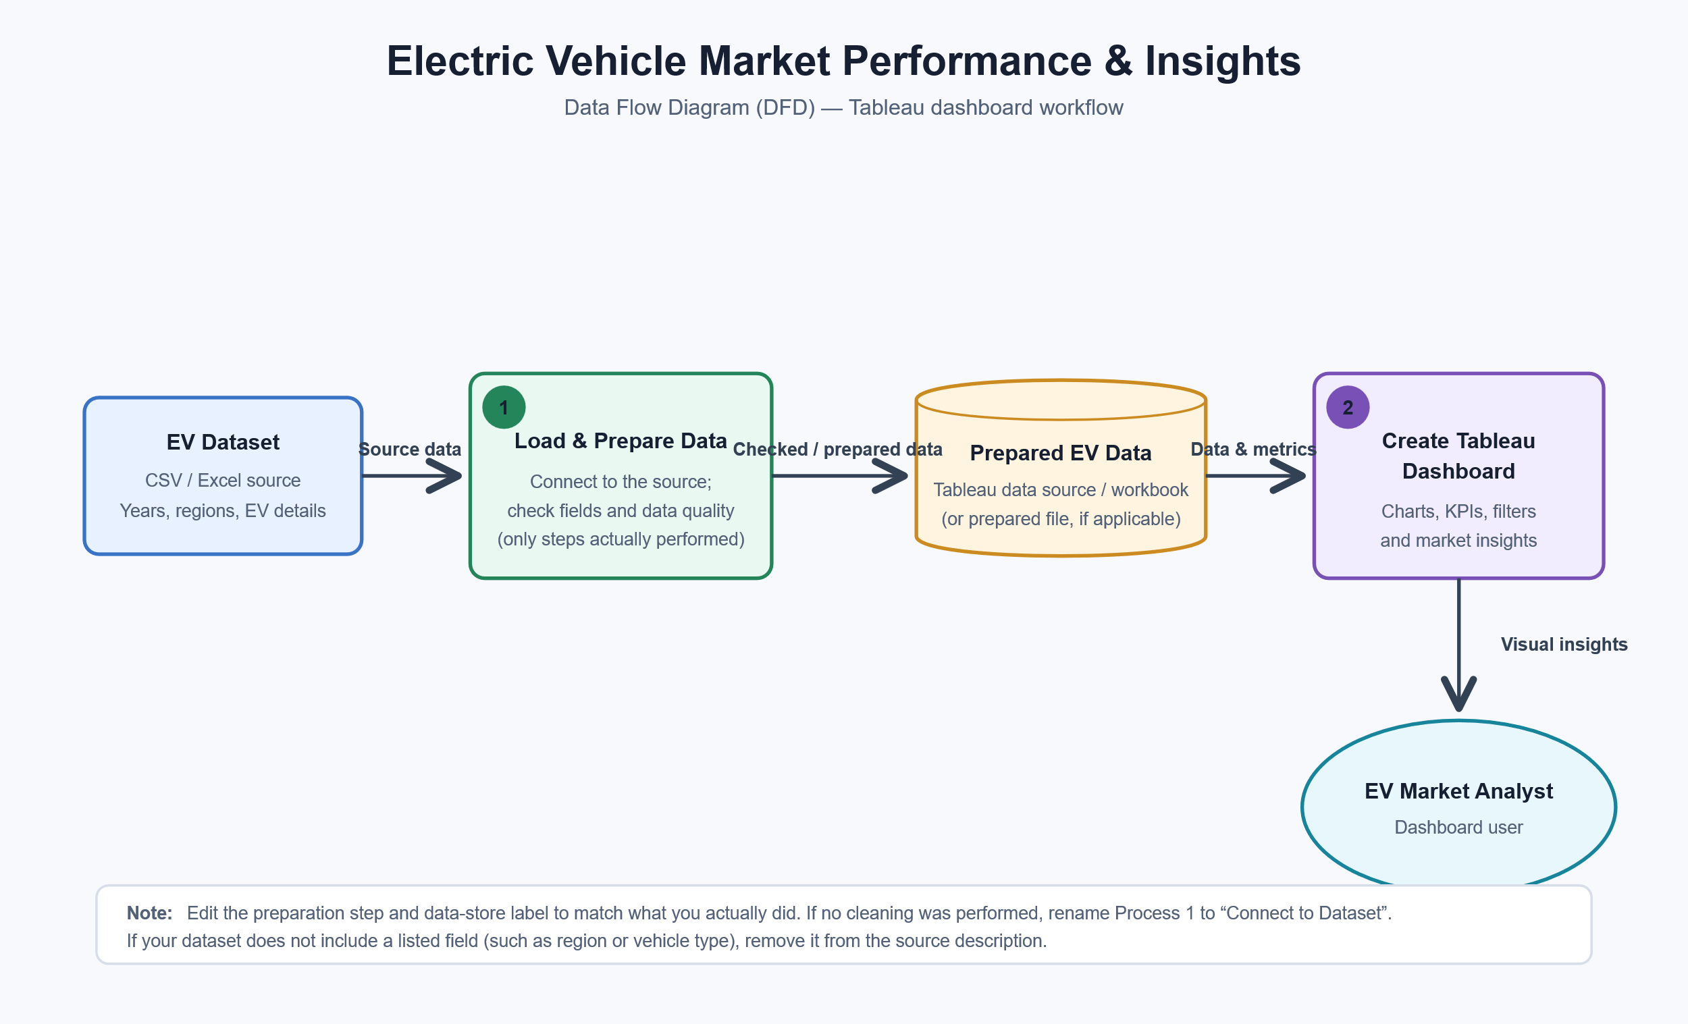

User Stories
Use the below template to list all the user stories for the product.
User Type | Functional Requirement (Epic) | User Story Number | User Story / Task | Acceptance criteria | Priority | Release
EV Market Analyst (Dashboard User) | View Dashboard | USN-1 | As an EV market analyst, I can view an overview of EV market performance so that I can understand the key metrics. | The dashboard displays the available EV metrics clearly and matches the source data. | High | Sprint-1
EV Market Analyst (Dashboard User) | Analyse Trends | USN-2 | As an EV market analyst, I can view EV trends by year so that I can identify changes over time. | The year-wise chart updates correctly and shows the years available in the dataset. | High | Sprint-1
EV Market Analyst (Dashboard User) | Compare Regions | USN-3 | As an EV market analyst, I can compare EV registrations across regions so that I can identify leading areas. | The comparison shows region names and values from the dataset. | High | Sprint-1
EV Market Analyst (Dashboard User) | Compare Vehicle type | USN-4 | As an EV market analyst, I can compare EV vehicle types so that I can understand their distribution. | The chart displays the vehicle types available in the dataset and their values. | Medium | Sprint-1
EV Market Analyst (Dashboard User) | Filter and explorer | USN-5 | As an EV market analyst, I can use dashboard filters so that I can explore the data for selected years, regions, or vehicle types. | Selecting a filter updates the relevant dashboard charts correctly. | High | Sprint-1

